Assignment : 3

Array coding question :

1. Find the Largest and Smallest Element

Given an array, find the smallest and largest elements in it.

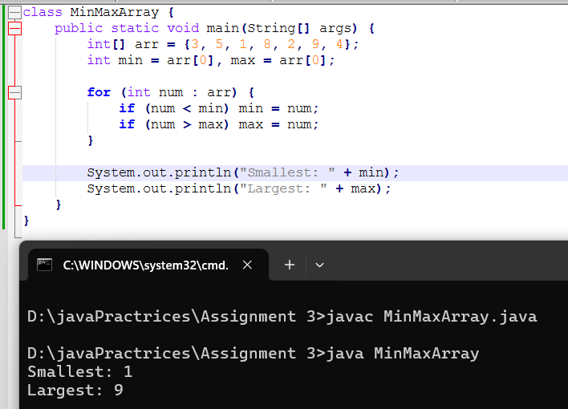

2. Reverse an Array

Reverse the given array in place.

3. Find the Second Largest Element

Find the second-largest element in the given array.

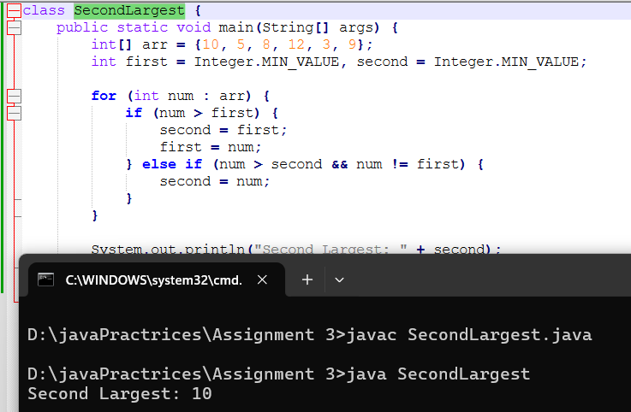

4. Count Even and Odd Numbers ○ Count the number of even and odd numbers in an array.

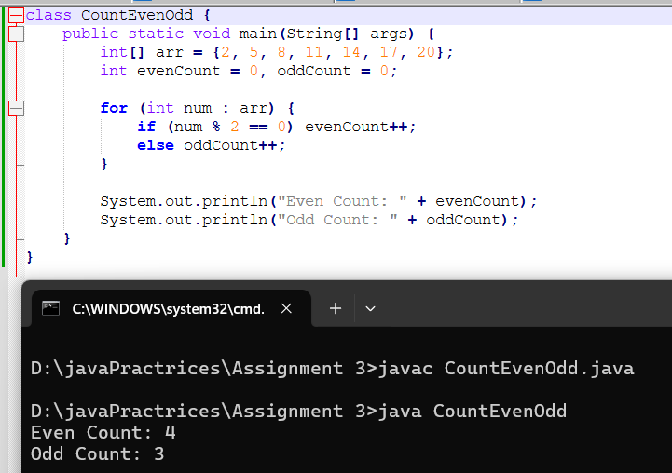

5. Find Sum and Average ○ Compute the sum and average of all elements in the array.

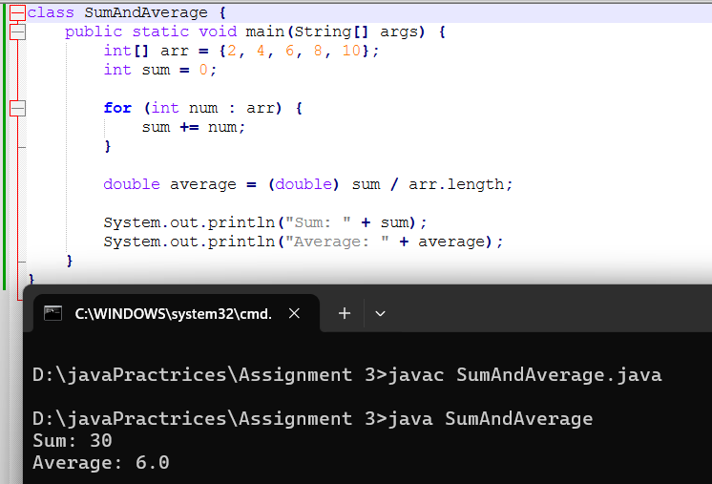

6. Remove Duplicates from a Sorted Array ○ Remove duplicate elements from a sorted array without using extra space.

7. Rotate an Array ○ Rotate the array to the right by k positions.

8. Merge Two Sorted Arrays ○ Merge two sorted arrays into a single sorted array without using extra space.

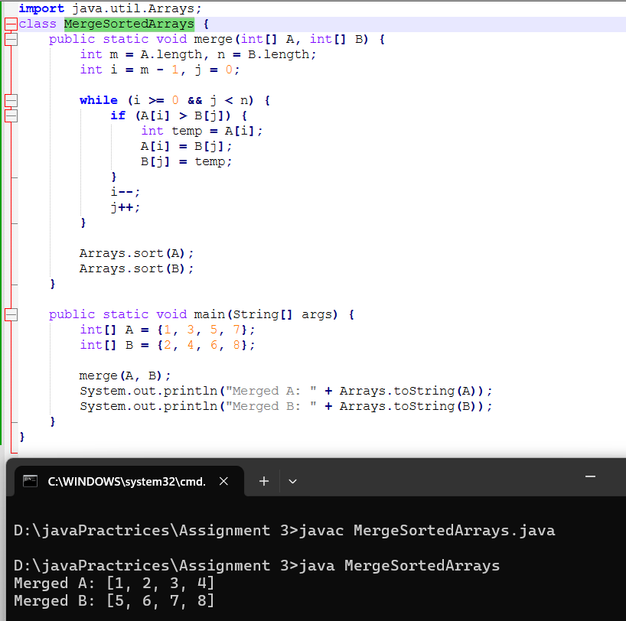

9. Find Missing Number in an Array ○ Given an array of size n-1 containing numbers from 1 to n, find the missing number.

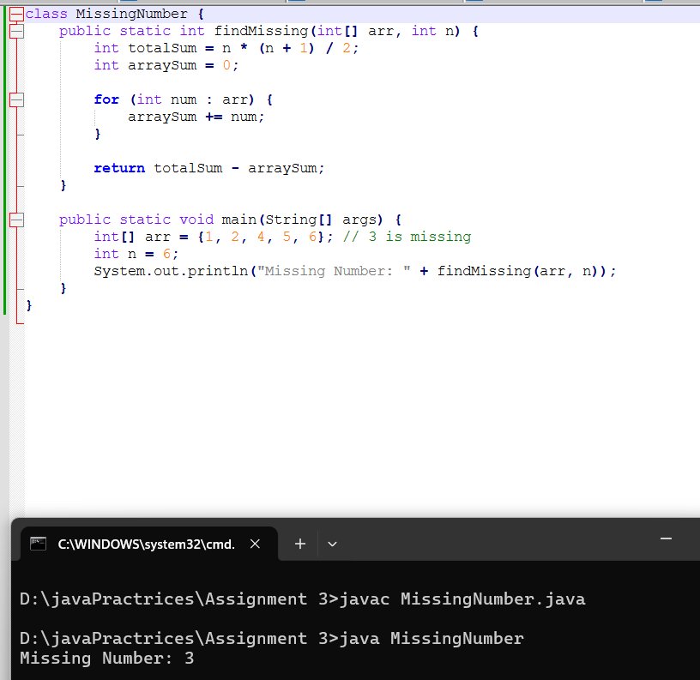

10. Find Intersection and Union of Two Arrays ○ Find the intersection and union of two unsorted arrays.

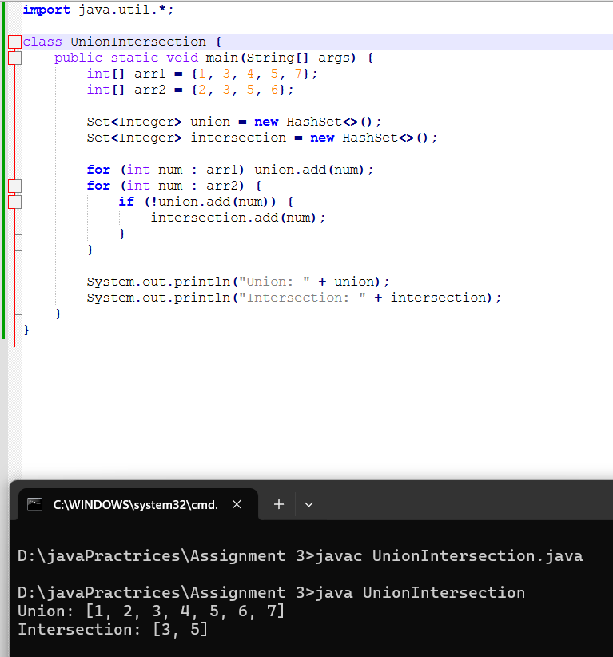

11. Find a Subarray with Given Sum ○ Given an array of integers, find the subarray that sums to a given value S.

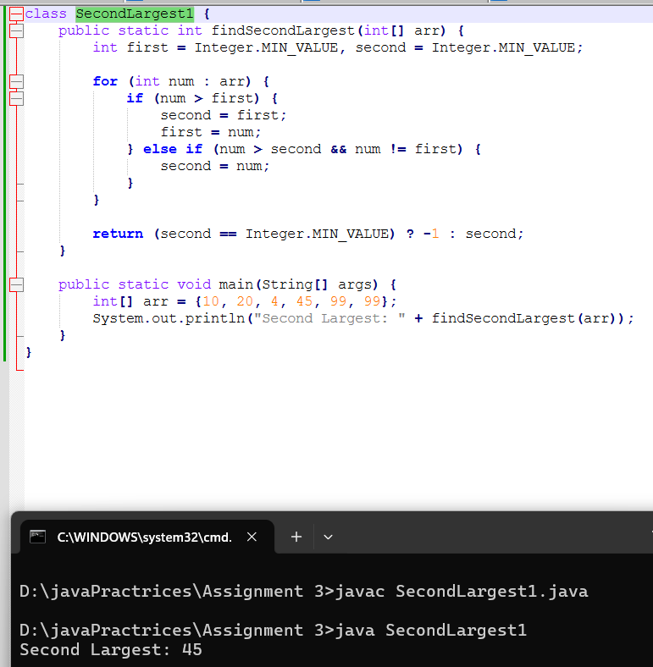

12. Write a program to accept 20 integer numbers in a single Dimensional Array. Find and Display the following: ○ Number of even numbers. ○ Number of odd numbers. ○ Number of multiples of 3

13. Write a program to accept the marks in Physics, Chemistry and Maths secured by 20 class students in a single Dimensional Array. Find and display the following: ○ Number of students securing 75% and above in aggregate. ○ Number of students securing 40% and below in aggregate.

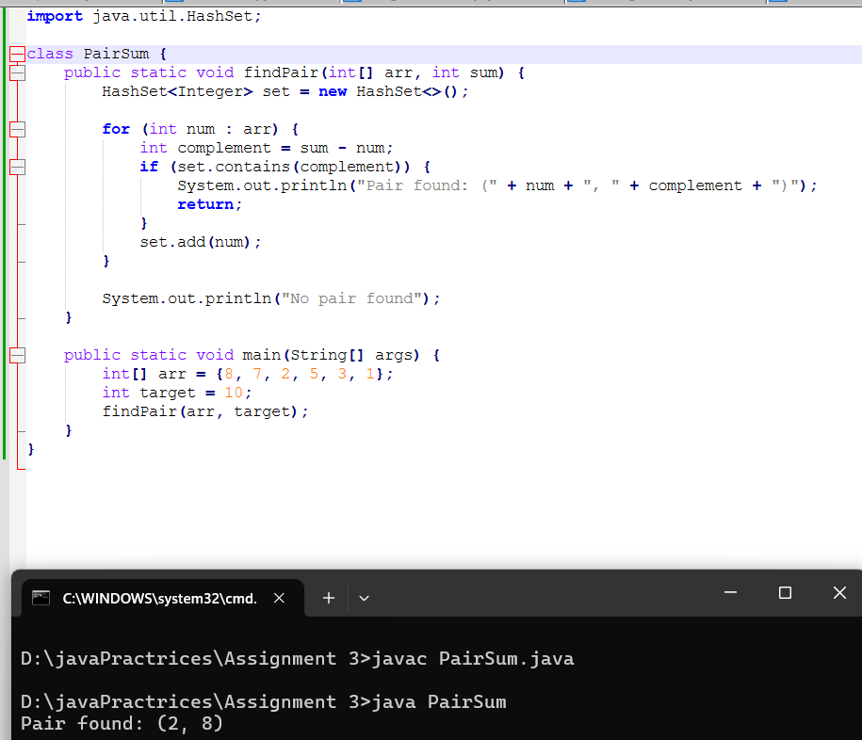

14. Write a program in Java to accept 20 numbers in a single dimensional array arr[20]. Transfer and store all the even numbers in an array even[ ] and all the odd numbers in another array odd[ ]. Finally, print the elements of the even & the odd array.

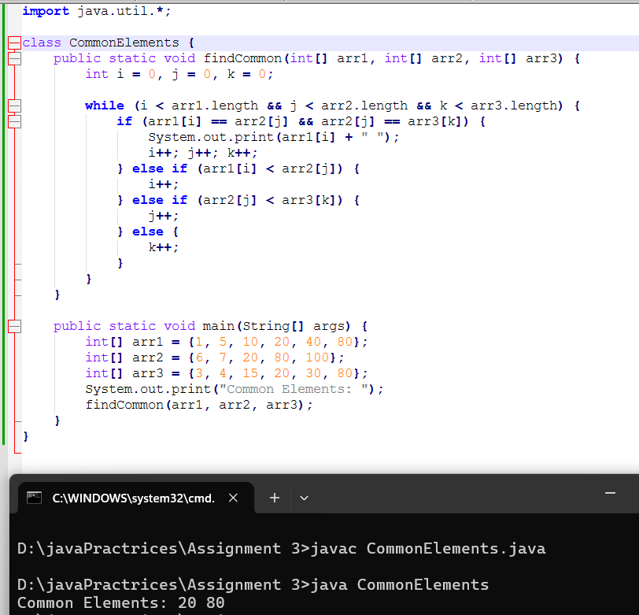

15. Write a Java program to print all sub-arrays with 0 sum present in a given array of integers. Example: Input : nums1 = { 1, 3, -7, 3, 2, 3, 1, -3, -2, -2 } nums2 = { 1, 2, -3, 4, 5, 6 } nums3= { 1, 2, -2, 3, 4, 5, 6 } Output: Sub-arrays with 0 sum : [1, 3, -7, 3] Sub-arrays with 0 sum : [3, -7, 3, 2, 3, 1, -3, -2] Sub-arrays with 0 sum : [1, 2, -3] Sub-arrays with 0 sum : [2, -2] CDAC Mumbai

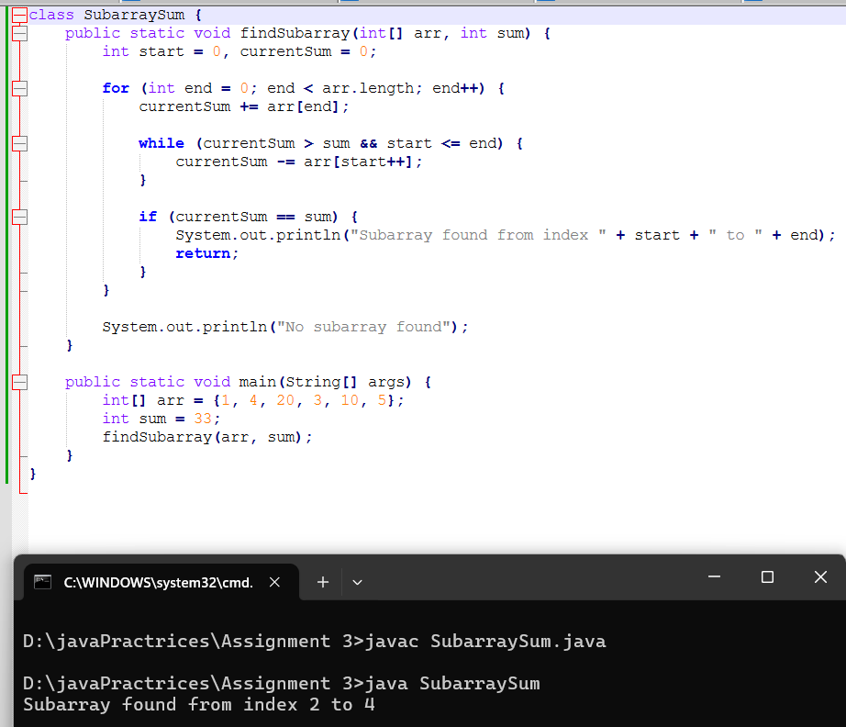

16. Given two sorted arrays A and B of size p and q, write a Java program to merge elements of A with B by maintaining the sorted order i.e. fill A with first p smallest elements and fill B with remaining elements. Example: Input : int[] A = { 1, 5, 6, 7, 8, 10 } int[] B = { 2, 4, 9 } Output: Sorted Arrays: A: [1, 2, 4, 5, 6, 7] B: [8, 9, 10]

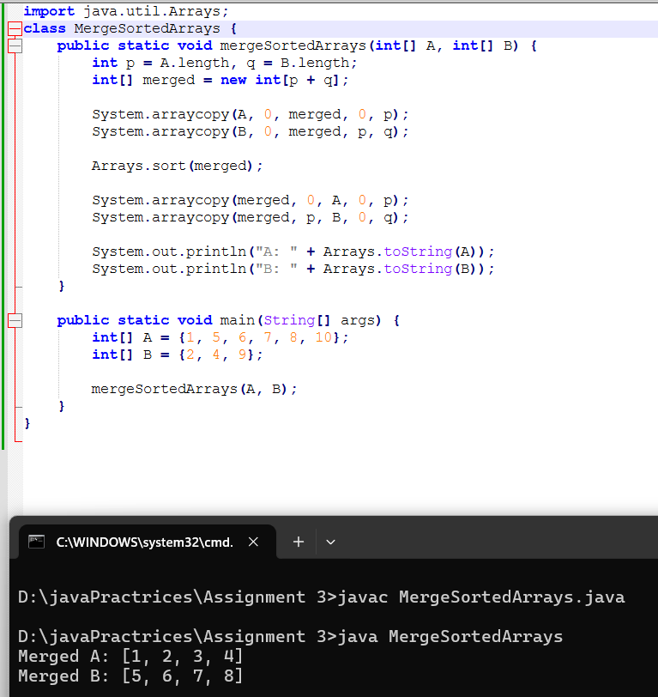

17. Write a Java program to find the maximum product of two integers in a given array of integers. Example: Input : nums = { 2, 3, 5, 7, -7, 5, 8, -5 } Output: Pair is (7, 8), Maximum Product: 56

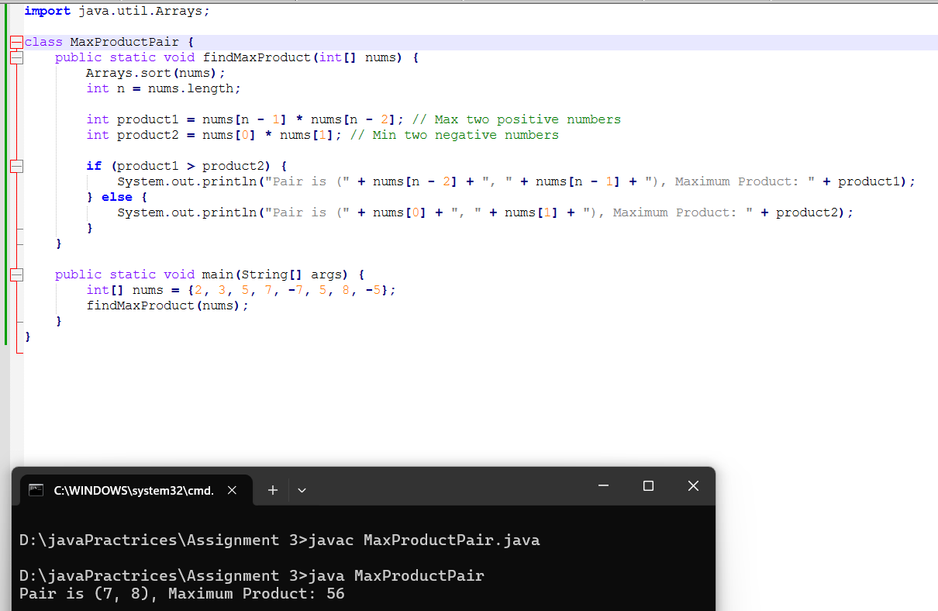

18. Print a Matrix ○ Given an m x n matrix, print all its elements row-wise.

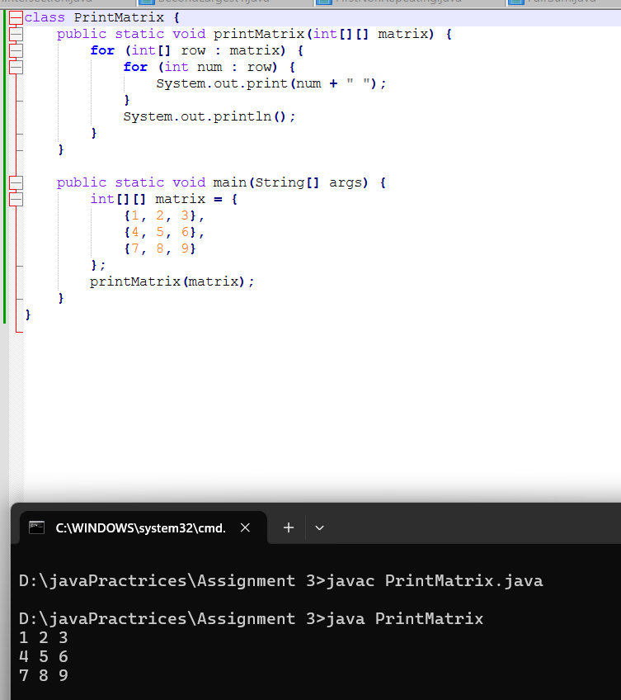

19. Transpose of a Matrix ○ Given a matrix, return its transpose (swap rows and columns).

20. Sum of Two Matrices ○ Given two matrices of the same size, compute their sum.

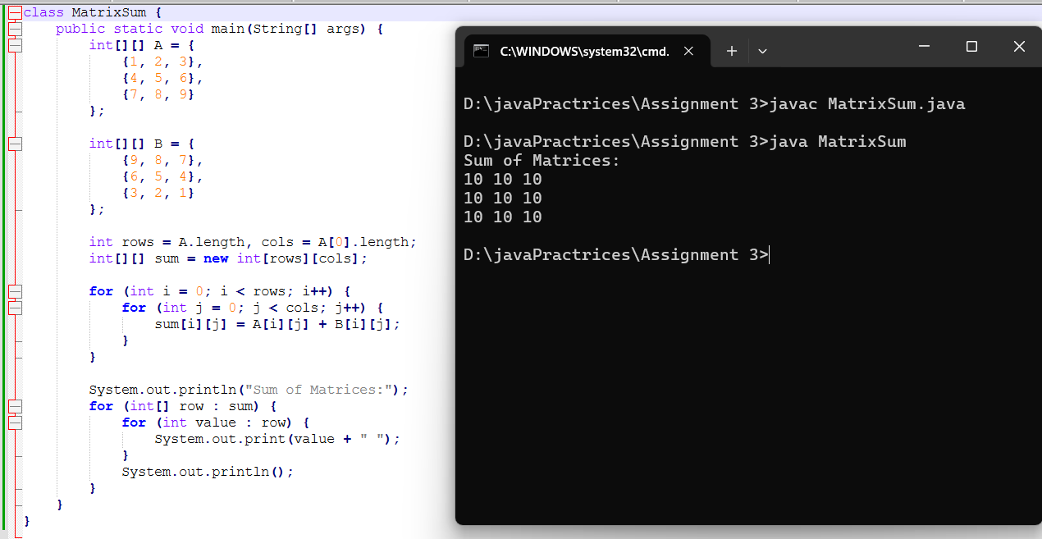

21. Row-wise and Column-wise Sum ○ Find the sum of each row and each column of a given matrix.

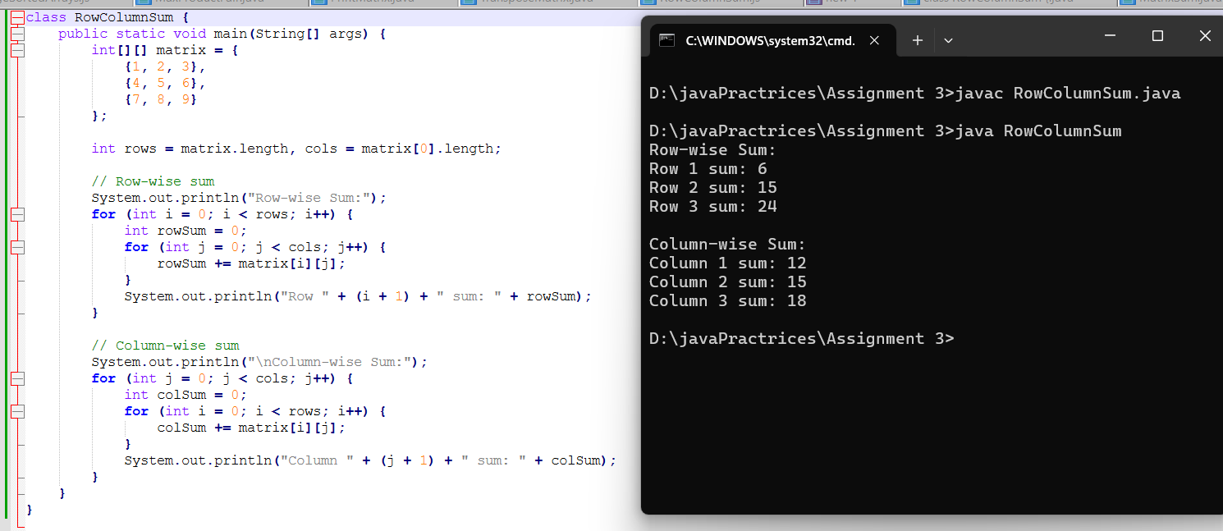

22. Find the Maximum Element in a Matrix ○ Find the largest element in a given matrix.

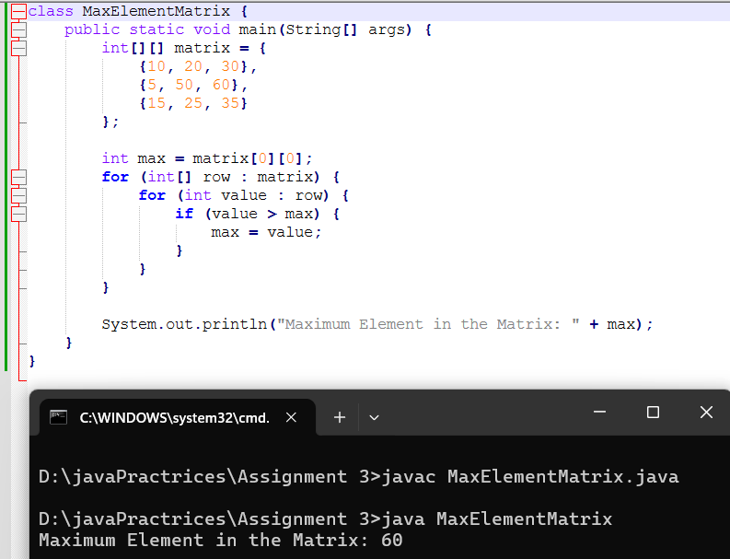

23. Matrix Multiplication ○ Multiply two matrices and return the resultant matrix.

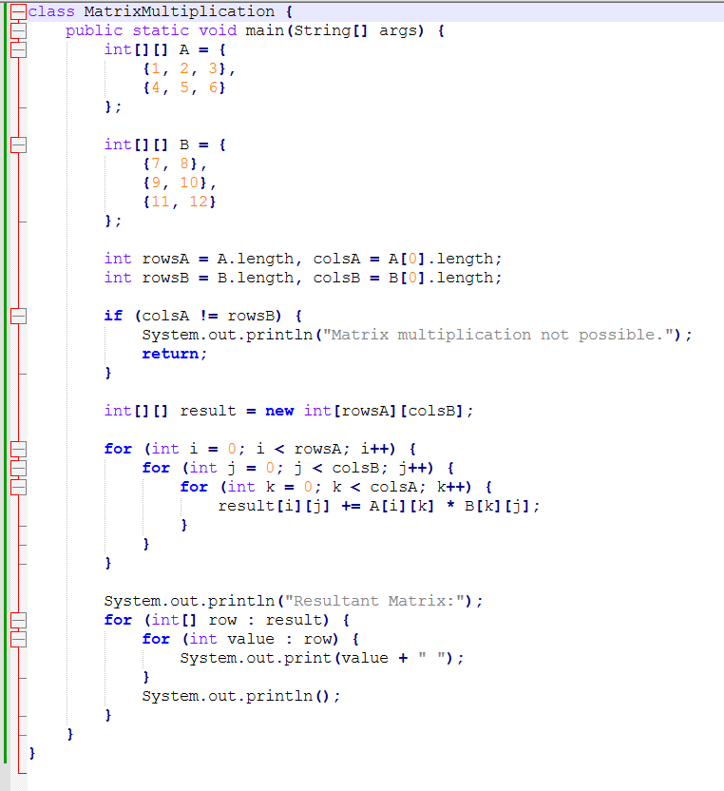

24. Rotate a Matrix by 90 Degrees ○ Rotate a given N x N matrix by 90 degrees clockwise.

25. Find the Diagonal Sum ○ Compute the sum of both diagonals in a square matrix.

